An Aggregator-Based Market Modelling with an Impact of Risk Under Uncertainty

Forecasted PV and wind output power Scenarios: Initially ARIMA forecasting is done based on available historical data on solar and wind output power.

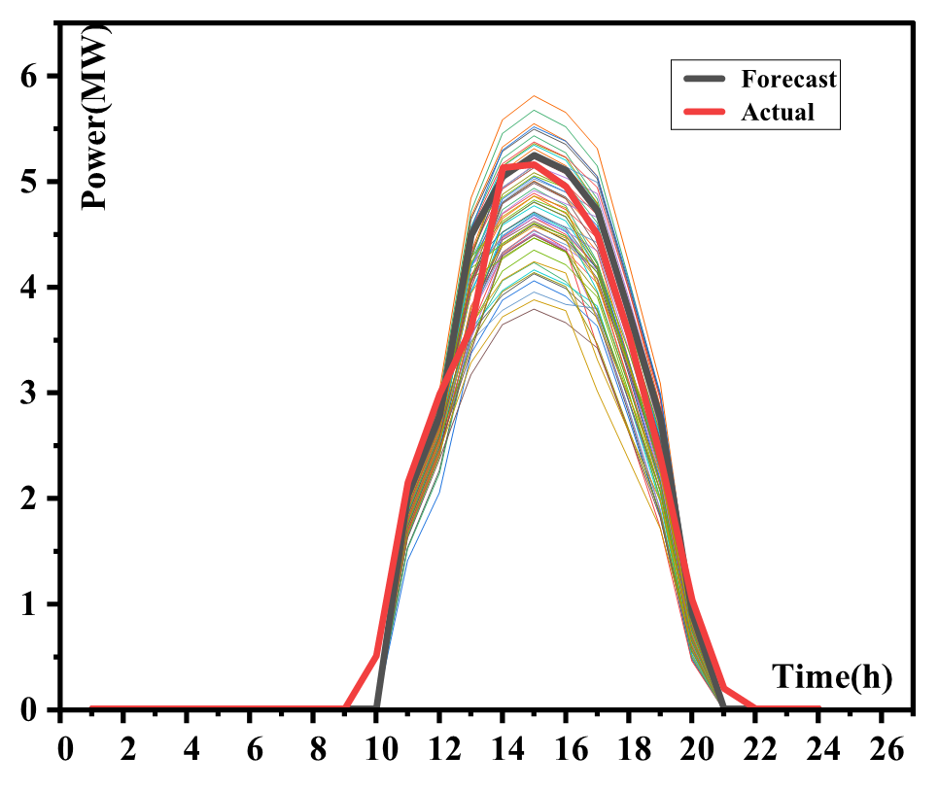

Fig 1: Forecasted solar output power Scenarios

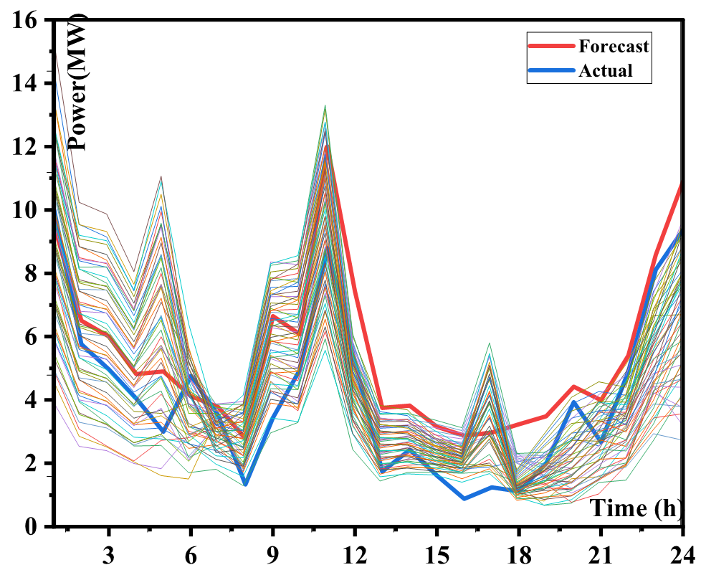

Fig2: Forecasted wind output power Scenarios

Forecasted Scenarios are reduced to five scenarios using the k-means clustering algorithm

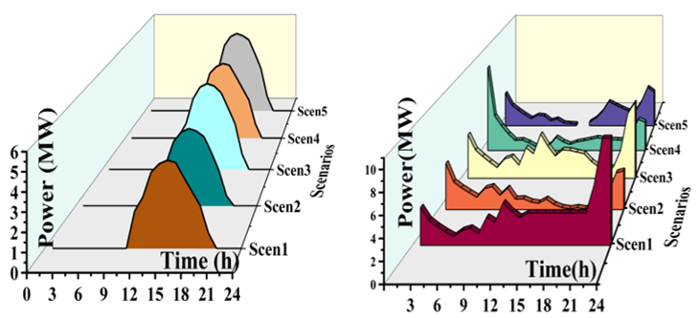

Fig3: Reduced Scenarios of solar and wind output power

For the Reduced scenarios a mathematical market modelling is performed in GAMS software which is a bi-level formulation where aggregators submit their energy bids to an operator and the operator then clears the market and generates price signals. To assess risk incurred in this modelling risk assessment is done using VaR, CVaR method,

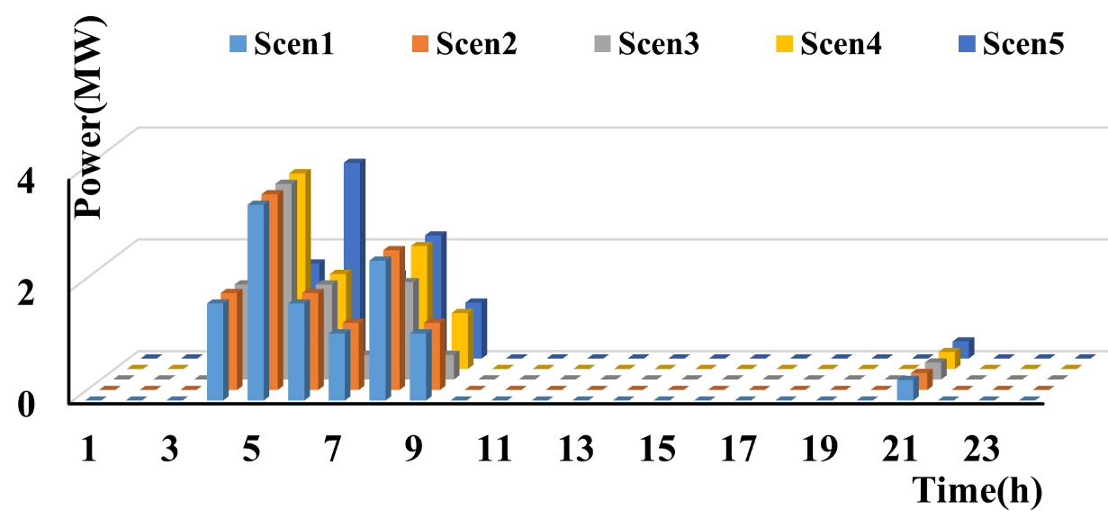

Fig 4: Diesel Generator Production of A1

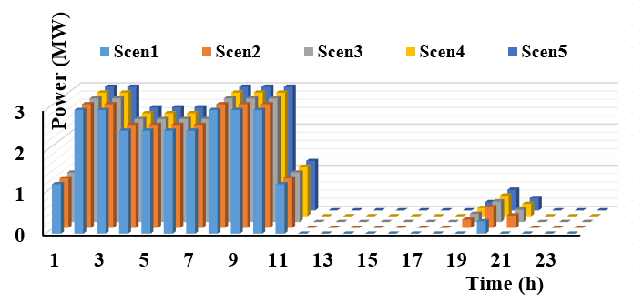

Fig 5: Diesel Generator Production of A2

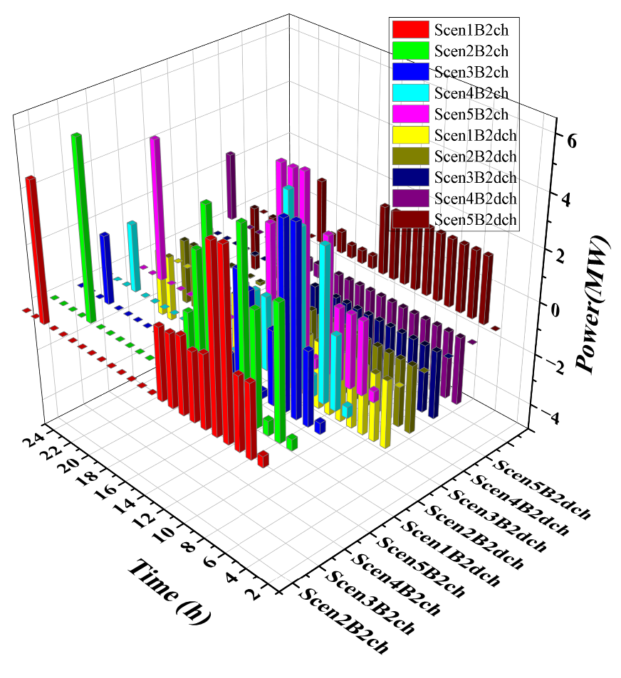

Fig 6: Battery2 of A2 Charging discharging levels

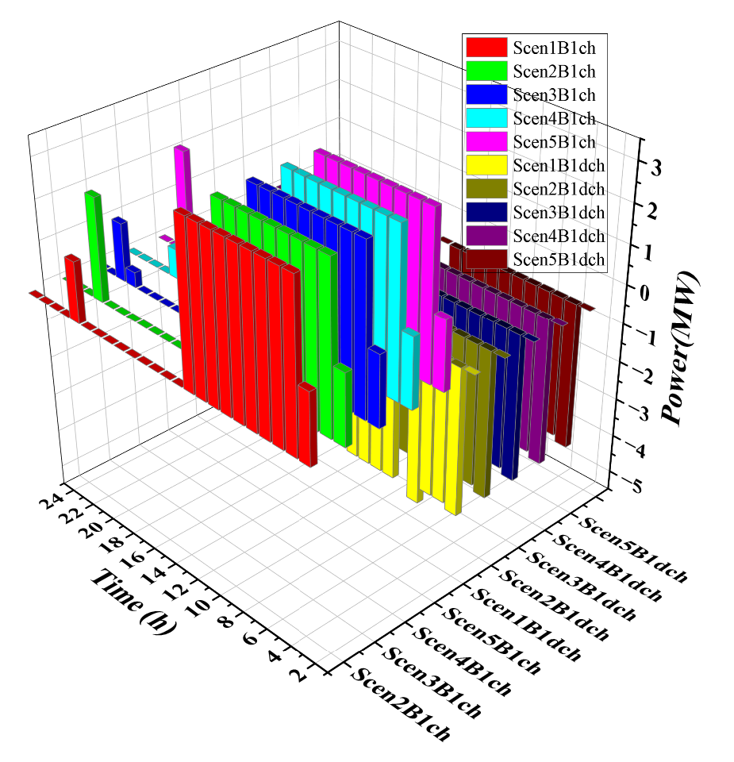

Fig 7: Battery1 of A2 Charging and discharging levels

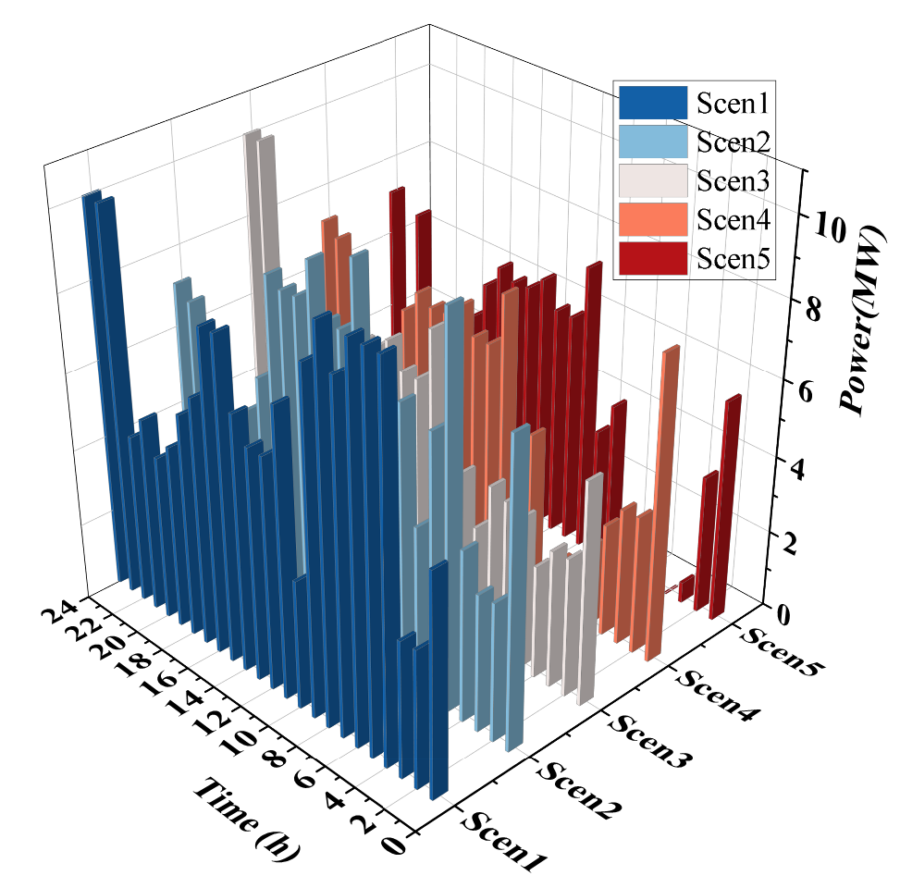

Fig 8: Total Production of A1

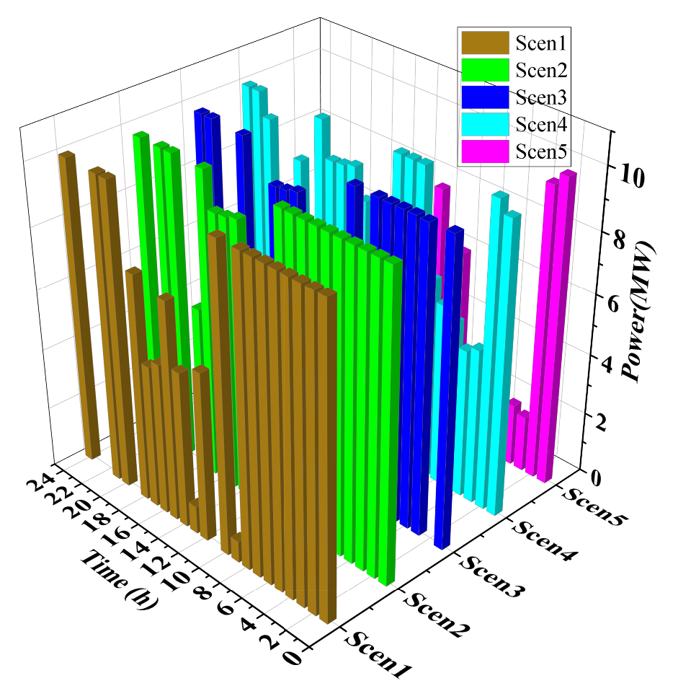

Fig9: Total Production of A2

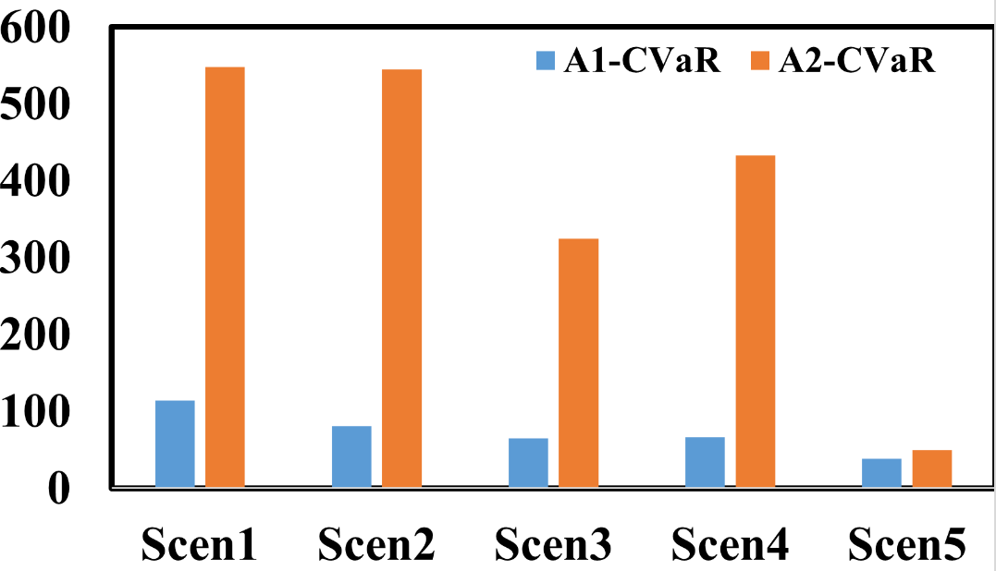

Fig 10: Comparison of CVaR of A1 and A2

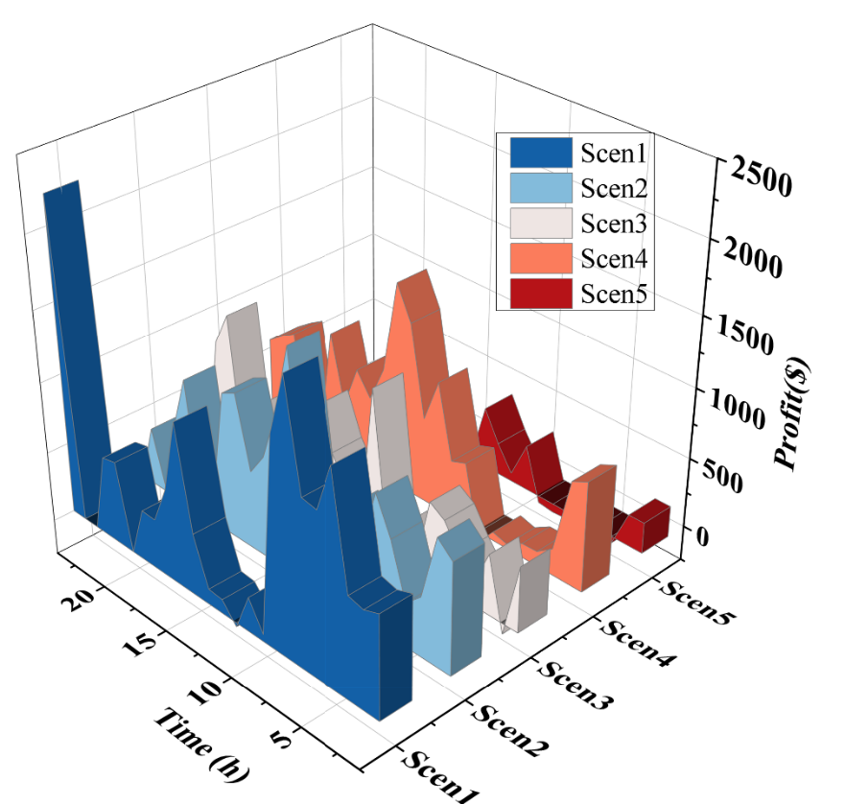

Fig 11: Profit of A1

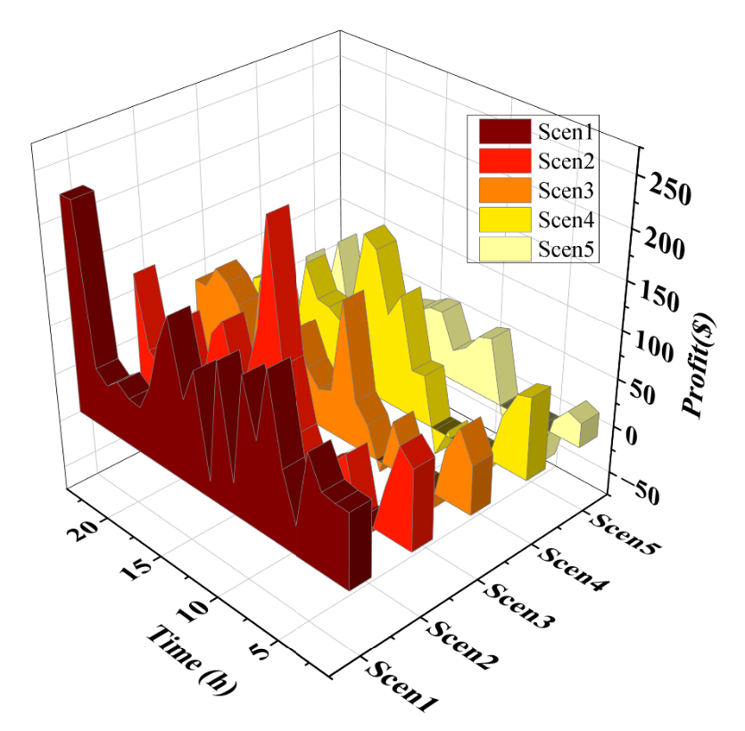

Fig 12: Profit of A2

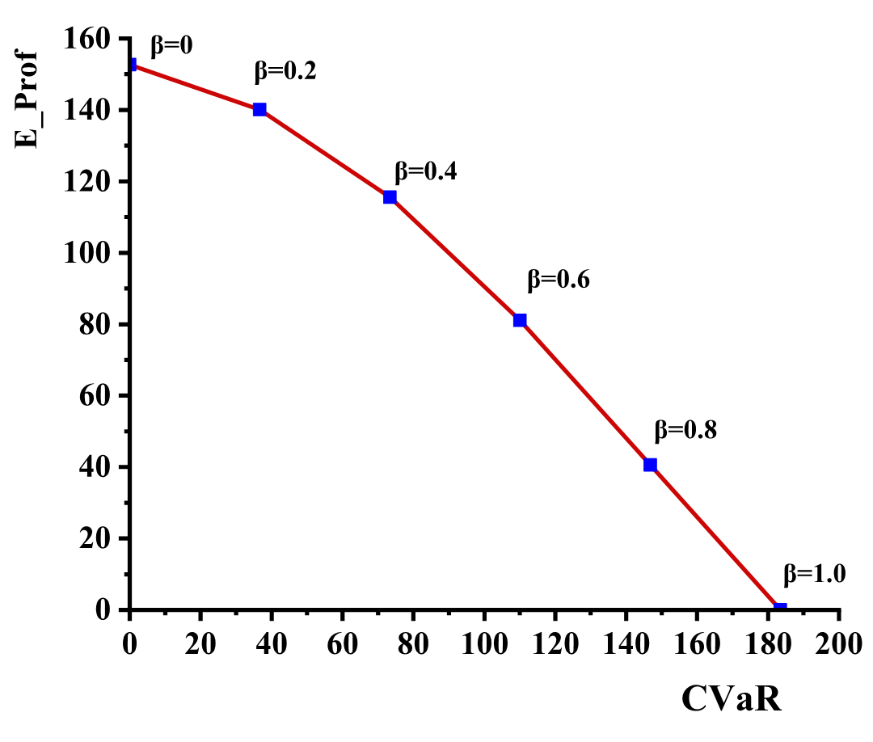

Fig 13: Comparison of CVaR and Profit of aggregator

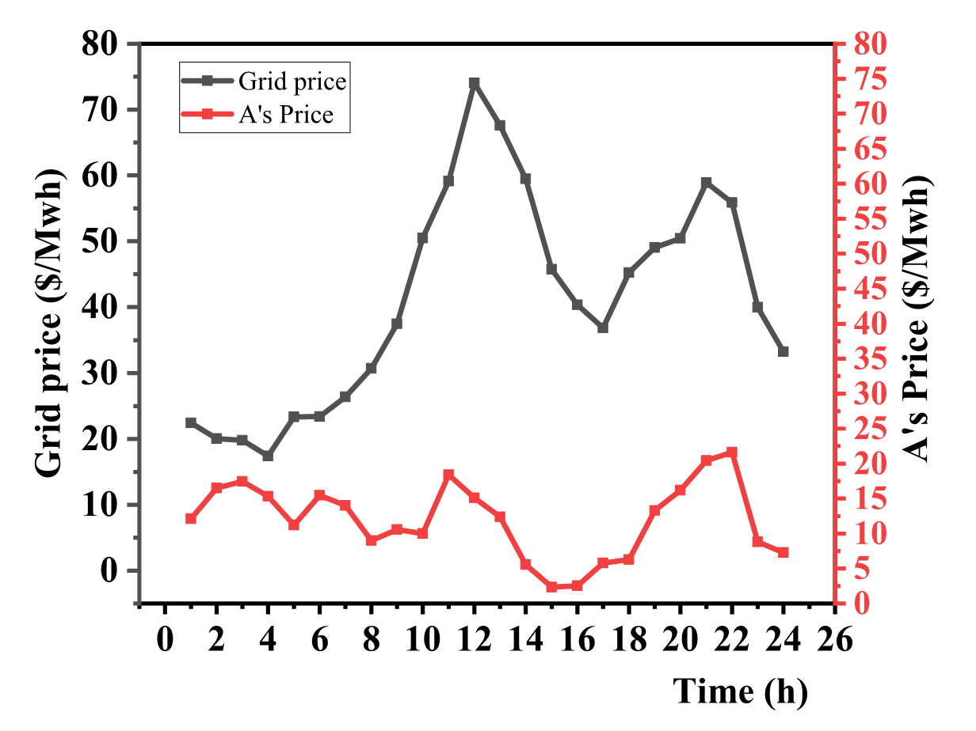

Fig 14: Day-ahead aggregator price signal in comparison with grid price

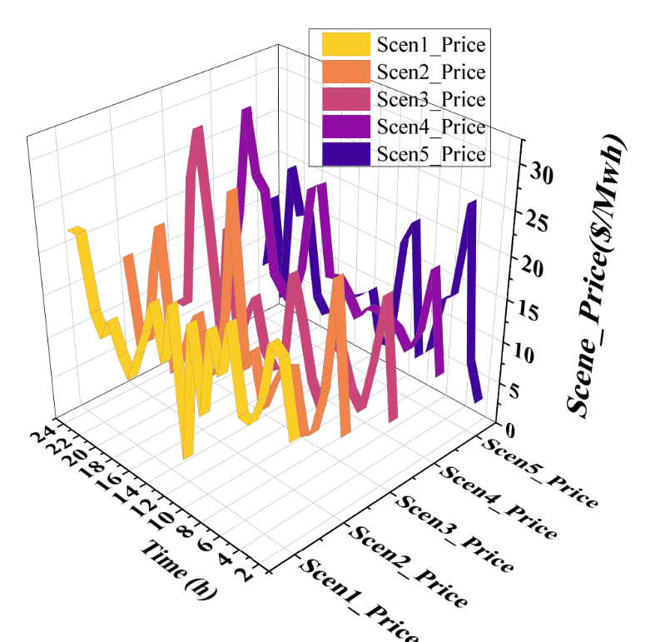

Fig 15: Scenario-based Price signals

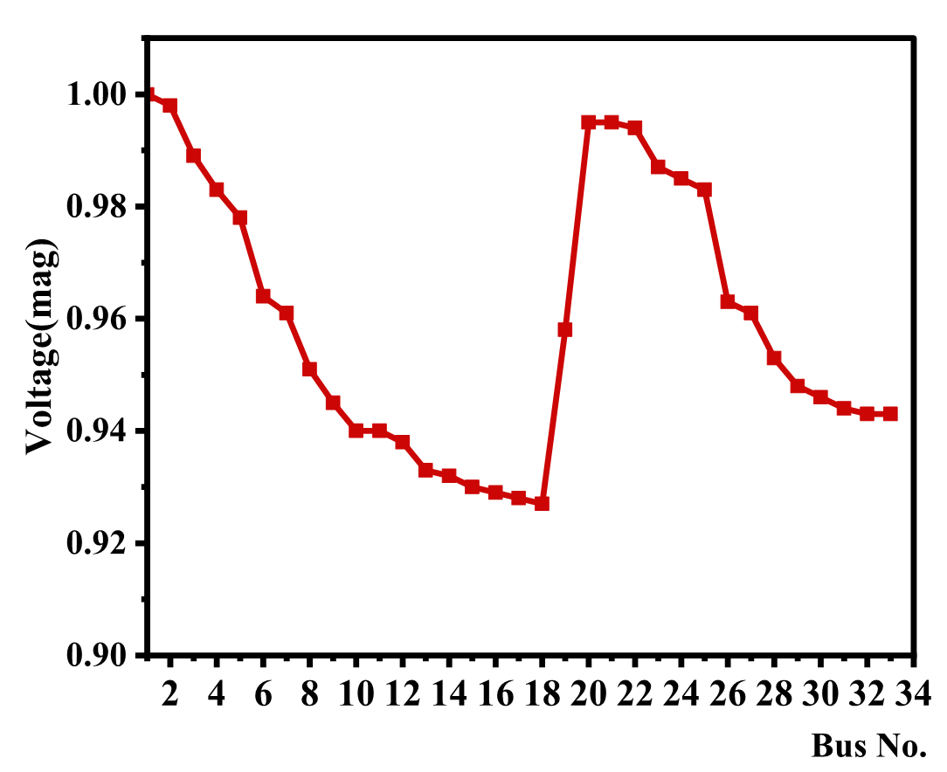

Fig 16: Voltage magnitude of opf execution for modified IEEE 33 bus test system